

**MEMORANDUM**

**DATE: October 10, 2009**

**TO: Laboratory Group C**

**Tyler Conner, Margaret Marshall, Amos Deloy**

**FROM: Tony Butterfield**

**Engineering Training Supervisor**

**SUBJECT: Crystal Violet CSTR**

For decades the senior lab has been using saponification of ethyl acetate as a model reaction to test our reactors. For a change of pace, we’re looking to find an alternative model reaction. We would also like to use a reaction that could make for a good demonstration and be monitored with the naked eye.

With those motivations in mind, we are considering the reaction of crystal violet (CV) with NaOH. CV has a color in neutral solutions near what one would anticipate by the name, with a maximum absorbance at about 595 nm, but it becomes clear as it reacts with a base.

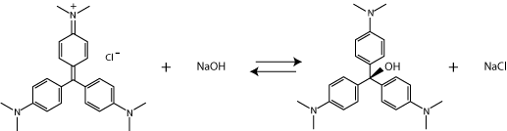

During the last project period, Group B found the kenetic constants for the reaction of CV with NaOH at room temperature using small batch reactions. You should consult with them before you begin this project. It would be helpful for you to know the detection limits they found with CV in the UV-Vis. However, you will most likely be using the spectrometer attached to the CSTR, to avoid the consumption of reactants that would be inevitable as you transferred samples from the CSTR to the UV-Vis. You will need to double check their findings and calibrate the CSTR’s spectrometer with the flow cell equipped.

Group B did not find the temperature dependence of the reaction rate in their small batch reactors due to the fact that temperature was not controllable within the UV-Vis. The CSTR you will be using has temperature control. Furthermore, while the batch reaction is logistically simpler, it is time consuming, and you should be able to more quickly analyze the reaction with the CSTR by varying flow rates.

Your task is then to quantify the temperature dependence of the CV-NaOH reaction using our CSTR, and evaluate it for use as a model reaction for our lab reactors. Confirm Group B’s findings at room temperature and run the reactor at a sufficient number of temperatures in order to determine the Arrhenius constants for this reaction. Also, please report if the conductivity meter attached to the CSTR might be used to double check spectrometry measurements for future work with this reaction.

Feel free to contact me with any questions you may have, and I look forward to meeting with you regarding this project on or before Monday, October 19, 2009.